ACKNOWLEDGEMENT

We would like to express our deepest appreciation to all those who provided us the possibility to complete this report. A special gratitude we give to Mr. Kamlesh Kumar Sir, whose contribution in stimulating suggestions and encouragement, helped us to coordinate our project especially in writing this report. Furthermore, we would also like to acknowledge with much appreciation the crucial role of the staff of B.I.ET, who gave the permission to use all required equipment and the necessary materials to complete the task. We are thankful and fortunate enough to get constant support from our seniors and every teaching staff of B.Tech department which helped us successfully complete our project. We would also like to extend our regards to all the non-teaching staff of B.Tech department for their timely support. We have to appreciate the guidance given by other supervisor as well as the panels especially in our project presentation that has improved our presentation skills thanks to their comment and advices. Our thanks and appreciations also go to each and every one of our colleagues for their encouragement and support in developing the project.

iv
ABSTRACT

In today’s busy and expensive life we are in a great rush to increase sales of goods and services in our business. But we are stuck at the moment how. So, we have come over with the idea to do their business online across the world. Technical Support aims to help everyone who are planning to boost their business and increase sales. TS is a Website where an individual can apply for making a website, android application, logo and many more for their business. Here businessman can apply for different types of digital services like different kinds of Website, Logo for company, any graphical illustration for their business, Android application, Business research, Digital Marketing and Network security. Here user have unlimited revision during the given time period to modify and update their service. TS gives opportunity to every individual to do their business online without more interference.

Keywords: android app, graphic design, business research, digital marketing, network security.

v
 |  | TABLE OF CONTENTS
BONAFIDE CERTIFICATE..................................................................................................................... |  |  | III
ACKNOWLEDGEMENT ...................................................................................................................... |  |  | IV
ABSTRACT ......................................................................................................................................... |  |  | V
TABLE OF CONTENTS........................................................................................................................ |  |  | VI
LIST OF FIGURES............................................................................................................................. |  |  | VIII
LIST OF TABLES................................................................................................................................. |  |  | IX
LIST OF ABBREVIATIONS.................................................................................................................... |  |  | X
CHAPTER 1 |  | ......................................................................................................................................... | 1
INTRODUCTION.................................................................................................................................. |  |  | 1
1.1 | BACKGROUND ................................................................................................................................ |  | 1
1.2 | LITERATURE REVIEW ........................................................................................................................ |  | 1
1.3 | PROBLEM DEFINITION...................................................................................................................... |  | 2
1.4 | OBJECTIVES.................................................................................................................................... |  | 3
1.5 | SCOPE AND LIMITATIONS.................................................................................................................. |  | 3
1.4.1 |  | Scope ...................................................................................................................................... | 3
1.4.2 |  | Limitations ............................................................................................................................. | 4
1.6 | REPORT ORGANIZATION ................................................................................................................... |  | 4
CHAPTER 2 |  | ......................................................................................................................................... | 5
REQUIREMENT ANALYSIS AND FEASIBILITY ANALYSIS........................................................................ |  |  | 5
2.1 | DATA COLLECTION METHODS............................................................................................................ |  | 5
2.1.1 |  | Source of Data .................................................................................................................. | 5
2.2 | REQUIREMENT SPECIFICATION ........................................................................................................... |  | 6
2.2.1 |  | Functional Requirements ....................................................................................................... | 6
2.2.2 |  | Non-Functional requirements ................................................................................................ | 7
2.3 | FEASIBILITY ANALYSIS....................................................................................................................... |  | 8
2.3.1 |  | Technical Feasibility ............................................................................................................... | 8
Hardware Specification ................................................................................................................... |  |  | 8
Software Specification .................................................................................................................... |  |  | 8
2.3.2 |  | Operational Feasibility ........................................................................................................... | 9
2.3.3 |  | Economic Feasibility ............................................................................................................... | 9
2.3.4 |  | Scheduling Feasibility ............................................................................................................. | 9
2.4 | STRUCTURED SYSTEM REQUIREMENTS .............................................................................................. |  | 10
2.4.1 |  | Data Modeling (ER Diagram) .......................................................................................... | 10
2.4.2 |  | Process Modeling (DFD-0 DFD-1) ....................................................................................... | 10
CHAPTER 3 |  | ....................................................................................................................................... | 11
SYSTEM DESIGN ............................................................................................................................... |  |  | 11
3.1 | SYSTEM ARCHITECTURE AND OVERVIEW............................................................................................ |  | 11
3.1.1 |  | Database Schema ........................................................................................................... | 11
3.1.2 |  | Data Dictionary ............................................................................................................... | 13
3.1.3 UML class diagram............................................................................................................... |  |  | 13
Class Diagram ............................................................................................................................... |  |  | 13
Sequence diagram ........................................................................................................................ |  |  | 14

vi
Input Output Diagram ................................................................................................................... |  |  | 15
CHAPTER 4 |  | ....................................................................................................................................... | 16
SYSTEM IMPLEMENTATION AND TESTING ....................................................................................... |  |  | 16
4.1 IMPLEMENTATION OVERVIEW ............................................................................................................. |  |  | 16
4.2 TOOLS USED .................................................................................................................................... |  |  | 16
4.2.1 |  | Front End Tools .................................................................................................................... | 17
4.2.2 Back End Tools ..................................................................................................................... |  |  | 17
4.2.3 |  | Module Description .............................................................................................................. | 18
4.3 TESTING.......................................................................................................................................... |  |  | 20
4.3.1 |  | Unit Testing .......................................................................................................................... | 20
4.3.2 |  | Integration Testing ............................................................................................................... | 21
4.3.3 |  | System Testing ..................................................................................................................... | 22
CHAPTER 5 |  | ....................................................................................................................................... | 23
CONCLUSION AND RECOMMENDATION........................................................................................... |  |  | 23
5.1 | CONCLUSION................................................................................................................................ |  | 23
5.2 | RECOMMENDATION....................................................................................................................... |  | 23
FUTURE SCOPE....................................................................................................................................... |  |  | 23
APPENDIX ........................................................................................................................................ |  |  | 25
QUESTIONNAIRE..................................................................................................................................... |  |  | 25
SCREENSHOTS........................................................................................................................................ |  |  | 25
CODES | .................................................................................................................................................. |  | 27
BIBLIOGRAPHY ................................................................................................................................. |  |  | 39
REFRENCES....................................................................................................................................... |  |  | 40

vii
LIST OF FIGURES

FIGURE 1: USE CASE DIAGRAM 6

FIGURE 2: ER DIAGRAM 10

FIGURE 3: SYSTEM ARCHITECTURE 11

FIGURE 4: UML CLASS DIAGRAM 14

FIGURE 5: SEQUENCE DIAGRAM OF ONLINE STORE 15

FIGURE 6: INPUT OUTPUT DIAGRAM FOR ONLINE SHOPPING 15
FIGURE 7: TESTING LEVEL 20

FIGURE 8: UNIT TESTING LIFE CYCLE 21

FIGURE 9: TYPES OF SYSTEM TESTING 22

FIGURE 10: HOME 25

FIGURE 11: SERVICES 25
FIGURE 12: ABOUT US 26

FIGURE 13: CONTACT US 26

viii

LIST OF TABLES

TABLE 1: Comparison of Online business and Traditional business 2

TABLE 3: Admin Login Table 12

TABLE 4: Product Description Table 12

ix
LIST OF ABBREVIATIONS

SEO

Search Engine Optimization

UI

User Interface

UML

Unified Modelling Language

HTML

Hypertext Markup Language

WBS

BPMN

Work Breakdown Structure

Business Process Modelling Notation

x

CHAPTER 1

INTRODUCTION

1.1 Background

TS is a digital service provider for those who wants to do their business online across the world in a less manpower. TS gives the basic infrastructure to their business like business logo, illustration for business, different kinds of websites, SEO for that website, android application and business research to take their business at next level and increase the sales. Online services brings the transparency in the business and provide a unique user experience to the customer. Online services decrease the paper work and paper wastage so we can say that online services is ecofriendly.

1.2 Literature Review

Attending office daily from one place it is very difficult, it becomes easier if business comes online to manage business by sitting anywhere in the world. In this series TS helps to bring your business online by using its services and mange your business anytime anywhere in the world. More than 1.8 billion people worldwide use the Internet in some way, shape or form, according to a December, 2009 study on internetworldstats.com. A significant portion of users are business owners who have learned the power of connecting with customers and colleagues electronically. Over time, a business owner's consistent use of the Internet can help propel his company to the next level.

One of the basic uses of the Internet for businesses is to sell products and services. Businesses create E-commerce websites to sell anything from cell phone contracts to books and CDs. Online selling eliminates the need for the business to maintain a brick-and-mortar store and in some cases they don't have to hold an inventory. A business can also use the Internet to buy items and services online, such as bulk-buying office supplies or printed materials.

1
Business owners use the Internet to monitor customer purchasing trends and interests. To discover what everyday people think about a particular product or service, business owners can visit online social networking sites and message boards. Taking in this feedback helps business owners make their products better. For example, car accessory businesses can visit car forums to find out what car enthusiasts want. A business owner can also use the Internet to connect and communicate with his customers through these same websites.

Comparison of Online business and Traditional business:

Table 1: Online business and Traditional business

Online Business | Traditional Business
Less manpower needed and easy to manage | More manpower needed and difficult to mange
Possible to manage anytime from anywhere | Not possible to manage anytime from anywhere
It decrease the paper waste | It increase the paper waste
Bring the more transparency in the business | Less transparency in traditional business
Consumer can access from anywhere | Consumer cannot access from anywhere
Overall business cast is low | Overall business cast is high

1.3 Problem Definition

Companies are continually searching for innovative ways to attract new customers and increase business. Traditional business methods are becoming less effective as consumers utilize technology to find and purchase products. Developing new advertising ideas is an effective way to acquire new business in a competitive market.

Most people need guidance when starting a new business. Some business owners contact other small business owners. Others read books or search online for guidance. Business startup advice allows people to avoid certain pitfalls or problems early on. Advice can be as simple as selecting the right location or choosing which products to sell. Most important, a business owner must have enough working capital to adequately operate her business.
2
Most important, a business owner must have enough working capital to adequately operate her business.

Business owners need to study their competition before opening their businesses. Some companies conduct a SWOT--strengths, weaknesses, opportunities and threats--analysis to better understand key competitors. For example, a company can study each competitor's strengths relative to its own strengths. Consequently, the company may be able to identify key advantages it has over competitors, including product quality or distribution channels. The company can then use these advantages to gain a competitive advantage over these competitors.

1.4 Objectives

The objective of this system are:

- Do business across the world
- Build a brand
- Increase revenue
- Manage online reputation
- Providing a unique customer experience
- Decrease the paper waste
- Opportunities to manage your business from anywhere in the world

1.5 Scope and Limitations

1.5.1 Scope

Another significant contributor to the growth of eCommerce in India in the future is the e-tailing industry which largely deals in providing jewelry, apparel and kitchen appliances online.

Websites like Flipkart, Myntra, Amazon, Snapdeal, Jabong, etc. are all examples of the enormous success of eCommerce in India. Due to these firms, India is one of the fastest growing eCommerce markets in Asia/Pacific with China investing as much.

3

1.5.2 Limitations

But it isn’t all good news. E-business does have certain disadvantages when compared to the traditional way of doing business. Some of the limitations of e-business are as follows:
- Security: One of the main limitations of eCommerce is security. In most cases, people are hesitant to provide their personal and financial details in spite of advanced data encryption security systems in place. Moreover, there are some websites that do not have the capability and features installed to authenticate transactions. As such, there are instances of fraudulent activities. The fear of providing financial information like credit card details hinders the growth of eCommerce.
- Lack of Privacy: To some extent, the privacy of a customer is compromised in eCommerce. You need to provide your personal details, such as an address, telephone number, and so on to the seller. There are still lots of sites that do not have the advanced technology to protect sensitive information. Moreover, there are also sites that illegally collect consumer statistics without permission. This is one reason why people get skeptical while using eCommerce.
- Fear: In spite of the popularity, there still resides an element of doubt in the mind of people when it comes to online shopping. This is because the customer cannot physically examine the product and is not sure about the features and attributes. This is why a lot of people prefer shopping from physical stores.
- Product Suitability: As already mentioned, it is not possible for people to physically examine the product in eCommerce. In many cases, the original product may not match the picture or specifications in the eCommerce site. This absence of ‘touch and feel’ creates a discouraging effect.

1.6 Report Organization

This is where the need to use a report tool and monitor when all of these little and big changes arise: knowing what is happening in your business is key to keep it afloat and be prepared to face any transformation or drastic shift. And business report templates are the best help for that. They may gather financial, marketing and sales-related information.
4

CHAPTER 2

REQUIREMENT ANALYSIS AND FEASIBILITY ANALYSIS

2.1 Data Collection Methods

Today’s online world data is a real value in a business, if you have more data means you have more strategy to grow your business. All prediction is taken over the data, if we have good quality and large amount of data we can take right decision. There is some methods are as fallows:

2.1.1 Source of Data
Customer data is a focus area all its own. From consumer behavior to predictive analytics, companies regularly capture, store, and analyze large amounts of quantitative and qualitative data on their consumer base every day. Some companies have built an entire business model around consumer data, whether they're companies selling personal information to a third party or creating targeted ads. Customer data is big business.

Types of consumer data businesses collect
The consumer data that businesses collect can be broken down into four categories:
- Personal Data. This category includes personally identifiable information such as Social Security numbers and gender as well as nonpersonally identifiable information, including your IP address, web browser cookies, and device IDs (which both your laptop and mobile device have).
- Engagement Data. This type of data details how consumers interact with a business's website, mobile apps, social media pages, emails, paid ads and customer service routes.
- Behavioral Data. This category includes transactional details such as purchase histories, product usage information (e.g., repeated actions), and qualitative data (e.g., mouse movement information).
5
2.2 Requirement Specification
2.2.1 Functional Requirement
Functional requirements are product features or functions that developers must implement to enable users to accomplish their tasks. So, it’s important to make them clear both for the development team and the stakeholders. Generally, functional requirements describe system behavior under specific conditions. For instance:
Requirements are usually written in text, especially for Agile-driven projects. However, they may also be visuals. Here are the most common formats and documents:
- Software requirements specification document
- Use cases
- User stories
- Work Breakdown Structure (WBS) (functional decomposition)
- Prototypes
- Models and diagrams
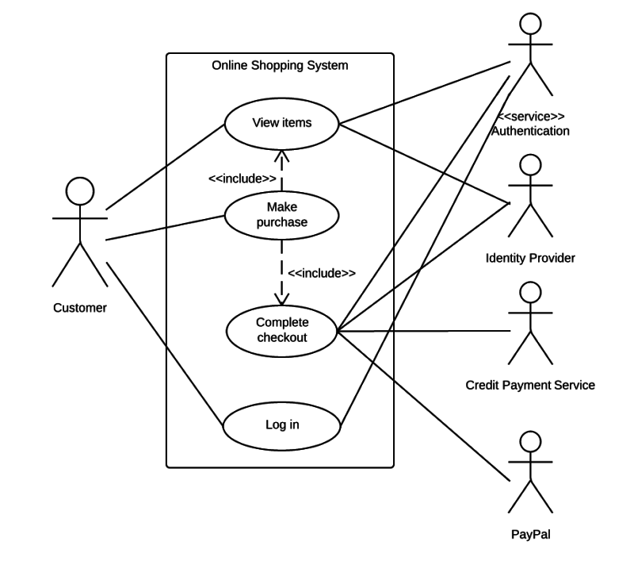
Figure 1. Use Case Diagram
6
2.2.2 Non-Functional requirements

Nonfunctional requirements describe how a system must behave and establish constraints of its functionality. This type of requirements is also known as the system’s quality attributes.

Security: Security requirements ensure that the software is protected from unauthorized access to the system and its stored data. It considers different levels of authorization and authentication across different users roles. For instance, data privacy is a security characteristic that describes who can create, see, copy, change, or delete information. Security also includes protection against viruses and malware attacks.

Reliability: Reliability defines how likely it is for the software to work without failure for a given period of time. Reliability decreases because of bugs in the code, hardware failures, or problems with other system components. To measure software reliability, you can count the percentage of operations that are completed correctly or track the average period of time the system runs before failing.

Performance: Performance is a quality attribute that describes the responsiveness of the system to various user interactions with it. Poor performance leads to negative user experience. It also jeopardizes system safety when it’s is overloaded.

Availability: Availability is gauged by the period of time that the system’s functionality and services are available for use with all operations. So, scheduled maintenance periods directly influence this parameter. And it’s important to define how the impact of maintenance can be minimized.

Scalability: Scalability requirements describe how the system must grow without negative influence on its performance. This means serving more users, processing more data, and doing more transactions. Scalability has both hardware and software implications. For instance, you can increase scalability by adding memory, you can compress data, use optimizing algorithms, etc.

7
2.3 Feasibility Analysis

A well-designed study should offer a historical background of the business or project, such as a description of the product or service, accounting statements, details of operations and management, marketing research and policies, financial data, legal requirements, and tax obligations. Generally, such studies precede technical development and project implementation.

2.3.1 Technical Feasibility

A technical feasibility study evaluates the details of how you intend to deliver a system or solution to the customers. You have to think in terms of materials, labor, business site, and technology that brings all of them together. The report you generate would be a tactical or logical plan.

Hardware Specification
Hardware is simple to access and obtain. Almost everyone has hardware in their home capable of helping them run a business. You must have quality equipment to successfully run a business and have a smooth startup process. The hardware you have will determine how easy your daily work is when running a small business. You need organization and the hardware needed will help you save money and time in the end.

External Hard Drive

Desktop/Laptop Computer

Network Server

Mobile device

Software Specification

E-commerce is a valuable way to make sales and profit. Today it is more present than ever considering the number of people who enjoy shopping online than going out to physical stores. Online stores and businesses offer convenience for customers and this is why the rate f online shopping grows as years go by.

There are certain requirements to get your store started online. Third-party sites and
8
companies help businesses get their websites running properly and help them gain traction and profit. There are dozens of companies offering assistance and feature to help with business startups.

2.3.2 Operational Feasibility

This assessment involves undertaking a study to analyze and determine whether—and how well—the organization’s needs can be met by completing the project. Operational feasibility studies also examine how a project plan satisfies the requirements identified in the requirements analysis phase of system development.

2.3.3 Economic Feasibility

This assessment typically involves a cost/ benefits analysis of the project, helping organizations determine the viability, cost, and benefits associated with a project before financial resources are allocated. It also serves as an independent project assessment and enhances project credibility—helping decision-makers determine the positive economic benefits to the organization that the proposed project will provide.

2.3.4 Scheduling Feasibility

This assessment is the most important for project success; after all, a project will fail if not completed on time. In scheduling feasibility, an organization estimates how much time the project will take to complete.

When these areas have all been examined, the feasibility analysis helps identify any constraints the proposed project may face, including:

- Internal Project Constraints: Technical, Technology, Budget, Resource, etc.
- Internal Corporate Constraints: Financial, Marketing, Export, etc.
- External Constraints: Logistics, Environment, Laws, and Regulations, etc.

9
2.4 Structured System Requirements

2.4.1 Data Modeling (ER Diagram)
The ecommerce database diagram is a type of entity-relationship diagram that is used to design database structures for ecommerce websites. An organized database is a crucial element in the success of an online store. As a result, starting with a diagram that will display all the details required by the business is a mandatory first step in achieving future goals.
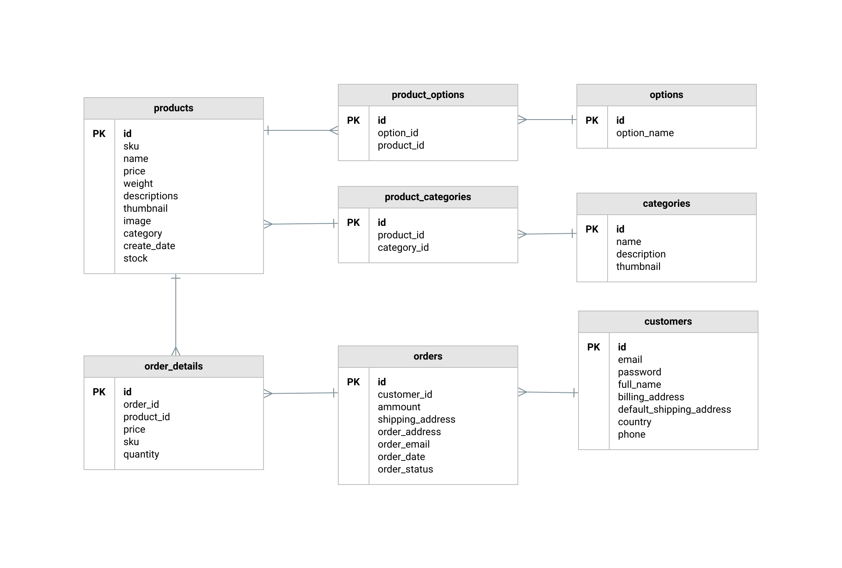

Figure 2. ER Diagram

2.4.2 Process Modeling (DFD-0 DFD-1)
BPMN consists of a series of symbols or “standard objects” to represent tasks and workflows. Of course, there’s nothing to stop you from developing your own set of symbols. However, using standardized ones makes collaboration with outside analysts easier and saves you from having to dream up a visual language of your own.

10
CHAPTER 3

SYSTEM DESIGN

3.1 System Architecture And Overview

E-business architectures control Web technologies to execute mission-critical e-business applications. These architectures utilize small-footprint clients to access services, provided by resource managers that can be accessed across a strong and consistent system. These customers can be browsers running on personal computers, network devices, personal digital assistants, cell phones, and other pervasive computing devices. The e-business architecture is advanced technology and it is above range of existing online technologies and products. It comprises of numerous architectural models and plan in that it explains a proposal that will meet the current and future needs of a different client population, and will adjust to varying business and technology needs.

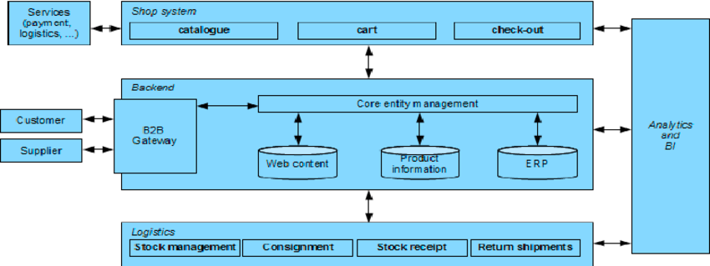

Figure 3. System Architecture

3.1.1 Database Schema

A database design is a collection of stored data organized in such a way that the data requirements are satisfied by the database. The general objective is to make information access easy, quick, inexpensive and flexible for the user. There are also some specific objectives like controlled redundancy from failure, privacy,

11
security and performance. A collection of relative records make up a table. To design and store data to the needed forms database tables are prepared. Two essential settings for a database are:

Admin Login Table:
Column Name | Data Types | Key Constraints | Extra
adminId | int(11) | Primary Key NOT NULL | auto_incre ment
username | varchar(40) | NOT NULL
password | varchar(40) | NOT NULL

Products Description Table:

Column Name | Data Type | Key Constraints
ProductId | int(20) | Primary Key NOT NULL
categoryName | varchar(20) | NOT NULL
subcategoryName | varchar(20) | NOT NULL
productName | varchar(200) | NOT NULL
price | int(10) | NOT NULL
discount | int(10) | NOT NULL
quantity | int(10) | NOT NULL
Description | int(10)

12
3.1.2 Data Dictionary

Essentially, a data dictionary provides a tool that enables you to communicate business stakeholder requirements in such a way that your technical team can more easily design a relational database or data structure to meet those requirements. It helps avoid project mishaps such as requiring information in a field that a business stakeholder can’t reasonably be expected to provide, or expecting the wrong type of information in a field.

A Data Dictionary provides information about each attribute, also referred to as fields, of a data model. An attribute is a place in the database that holds information. For example, if we were to create a Data Dictionary representing the articles here on Bridging the Gap, we’d potentially have attributes for article title, article author, article category, and the article content itself.

3.1.3 UML class diagram

Class Diagram

Here we provide an example of UML class diagram which shows a domain model for online shopping. The purpose of the diagram is to introduce some common terms, "dictionary" for online shopping - Customer, Web User, Account, Shopping Cart, Product, Order, Payment, etc. and relationships between. It could be used as a common ground between business analysts and software developers.

Each customer has unique id and is linked to exactly one account. Account owns shopping cart and orders. Customer could register as a web user to be able to buy items online. Customer is not required to be a web user because purchases could also be made by phone or by ordering from catalogues. Web user has login name which also serves as unique id. Web user could be in several states - new, active, temporary blocked, or banned, and be linked to a shopping cart. Shopping cart belongs to account.

13
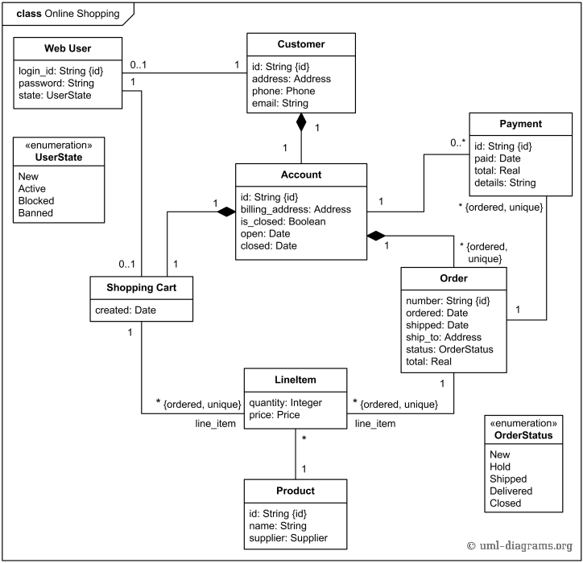
Figure 4. UML Class Diagram

Account owns customer orders. Customer may have no orders. Customer orders are sorted and unique. Each order could refer to several payments, possibly none. Every payment has unique id and is related to exactly one account.

Sequence diagram

UML Sequence Diagrams are interaction diagrams that detail how operations are carried out. They capture the interaction between objects in the context of a collaboration. Sequence Diagrams are time focus and they show the order of the interaction visually by using the vertical axis of the diagram to represent time what messages are sent and when.

A sequence diagram simply depicts interaction between objects in a sequential order i.e. the order in which these interactions take place. We can also use the terms event diagrams or event scenarios to refer to a sequence diagram.

14
Sequence diagrams describe how and in what order the objects in a system function. These diagrams are widely used by businessmen and software developers to document and understand requirements for new and existing systems.

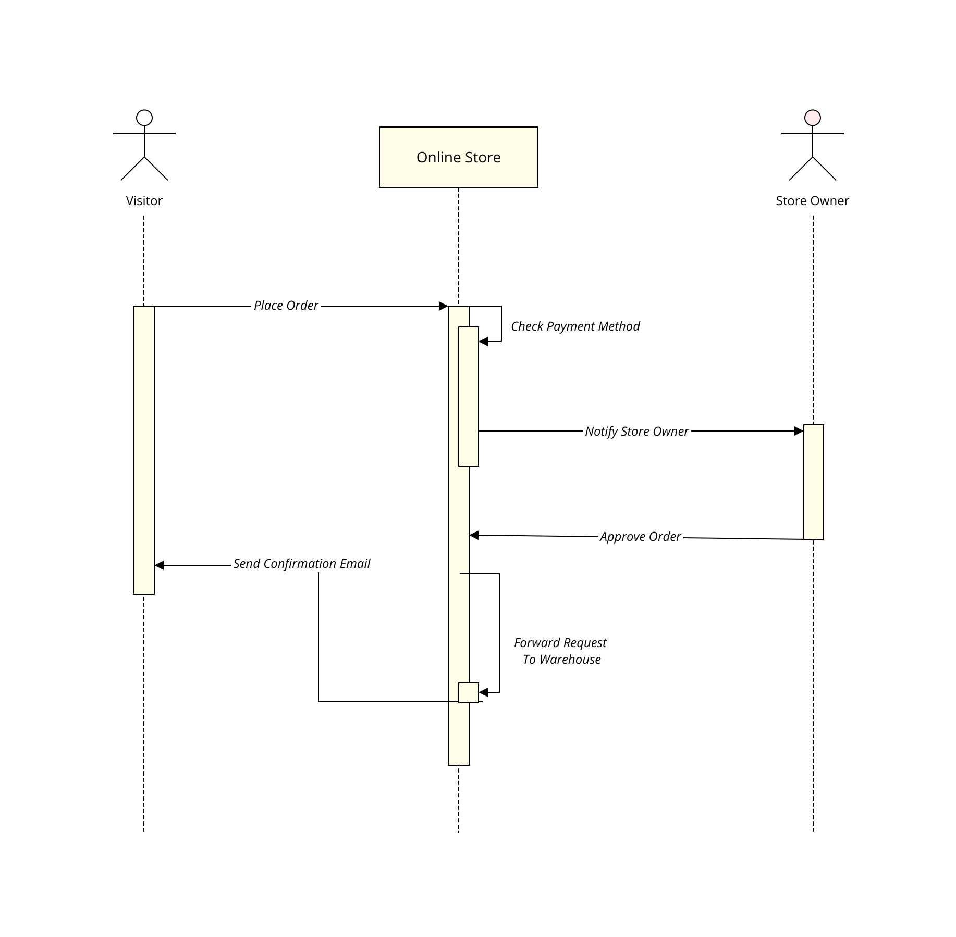

Figure 5. Sequence Diagram Of Online Store

Input Output Diagram
The user is all people who operate or visit our website. User is a customer of a website. User can first select product for buy, user must have to register in our system for purchase any item from our website. after register he can login to site and buy item by making online payment through any bank debit card or credit card.
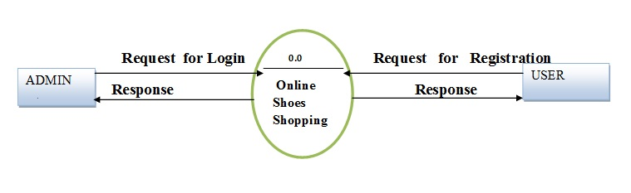
Figure 6. Input Output Diagram For Online Shopping
15
CHAPTER 4

SYSTEM IMPLEMENTATION AND TESTING

4.1 Implementation Overview
We intend to become the leader and most creative provider of Web-based business management applications on the market. We aim to create a user-friendly application that will be an integral component in any personal or business environment. We will do this by developing an innovative and progressive development and management team. We will also accomplish our goal by using customer input to further develop our products and services.

We will leverage this new product in the computer software industry to dominate the growing Web-based applications market, especially the small businesses. We have a premium, value-added product with three different packages from which the user can choose the one that best suits their needs. These strategic product lines will enable domination of the target market. The products all share the core applications but differ in range of services.

4.2 Tools Used
Understanding the secrets of growth in business is the beginning of success. Small businesses and startups aim to sore to greater heights by taking advantage of the most common elements of today's world: technology.

Successful businesses keep abreast with the digital world and remain in sync with technological innovators. As a tech-savvy business owner or leader, you don't have to move mountains or break down walls in order to ensure your business thrives – you just have to use the best online business tools.

In fact, it’s amazing how using the right tools for business can make a difference. Below you'll find a list with tools used by enterpreneurs and teams for customer service, communication, accounting, project management, and more.

16
4.2.1 Front End Tools

Frontend is what appears on the user’s side most and what entices the users to give the website a stroll. Hence, the designers work at the base level of this process. The UI designer and UX engineer both works collaboratively to make the website appear at its best with less delay and amazing easy to navigate functionalities. The aim to choose the most creative and useful technologies are:

- Make the website look great
- Build the website to load faster
- Increase responsiveness and device portability

With the advent of HTML5, Canvas, web application developers now have the smart scripting languages, particularly AJAX and Action-script, incorporated into the most of the all modern browsers like chrome, Firefox, IE10 and more. Dependability on plugins are less nowadays.

However, below is a summary of some of the mostly using Front-end Technologies which our developers have expertise in:

HTML

JavaScript
- CSS (Cascading Style Sheet)

Responsive Web Design

4.2.2 Back End Tools

If the back doesn’t support well, there will be no more standing ecommerce website to survive the competitive market or so it seems. Technologies are pretty complex and boring in back-end. But, the developers know what can make the process more interesting. That is to use right technology to do the right functionality work well.

Let’s talk back-end now, the skeleton behind the beautiful and enticing website we have been building for years.

PHP

MySQL

Java
17
4.2.3 Module Description

Magento is a feature-rich, professional open-source eCommerce solution that offers merchants complete flexibility and control over the look, content, and functionality of their online store.

Checkout
- One-Page Checkout
- SSL security support for orders on both front-end and back-end
- Shipping to multiple addresses in one order
- Checkout without account/Guest Checkout
- Shopping Cart with tax and shipping estimates

Shipping
- Integrated for real-time shipping rates
- Shipping to multiple addresses in one order
- On-site order tracking from customer accounts
- Flat rate shipping per item

Payment
- Configurable to authorize and charge, or authorize only and on creation of invoices
- Integrated with multiple PayPal gateways
- Saved Credit Card method form off-line payments
- Accept Checks/Money Orders
- Accept Purchase Orders

Customer Accounts
- Order status and history
- Re-orders from account
- Recently ordered items
- Default Billing and Shipping addresses
- Wishlist with ability to add comments
- Email or Send RSS feed of Wishlist
- Product Reviews submitted
18

Catalog Management
- Inventory Management with Backordered items, Minimum and Maximum quantities
- Batch Import and Export of catalog
- Batch Updates to products in admin panel
- Google Base Integration
- Virtual Products
- Downloadable/Digital Products
- Create Store-specific attributes on the fly

Order Management
- View, edit, create and fulfill orders from admin panel
- Create one or multiple invoices, shipments and credit memos per order to allow for split fulfillment
- Print invoices and packing slips
- Email Notifications of Orders

Search Engine Optimization
- 100% Search Engine Friendly
- Google Site Map
- URL Rewrites give full control of URL's
- Meta information for products and categories
- Auto-generated Site Map for display on site
- Auto-Generated Popular Search Terms Page

Site Management
- Control multiple websites and stores from one Administration Panel with ability to share as much or as little information as needed
- Multi-Lingual
- Support for localization
- Support for multiple currencies
- Administration Permission system Roles and Users
- Marketing Promotions and Tools

19
4.3 Testing

eCommerce testing is defined as testing of an eCommerce (online shopping) application. It helps in the prevention of errors and adds value to the product by ensuring conformity to client requirements.
he objective of testing is to ensure
- Software reliability
- Software quality
- System Assurance
- Optimum performance and capacity utilization
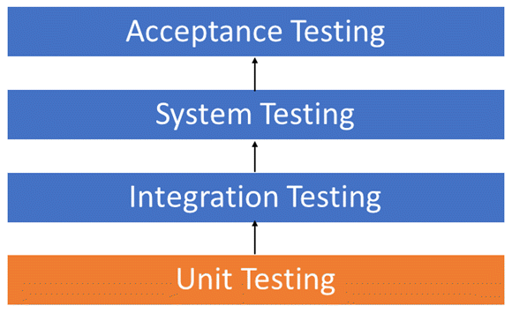
Figure 7. Testing Level
4.3.1 Unit Testing
UNIT TESTING is a type of software testing where individual units or components of a software are tested. The purpose is to validate that each unit of the software code performs as expected. Unit Testing is done during the development (coding phase) of an application by the developers. Unit Tests isolate a section of code and verify its correctness. A unit may be an individual function, method, procedure, module, or object.

20
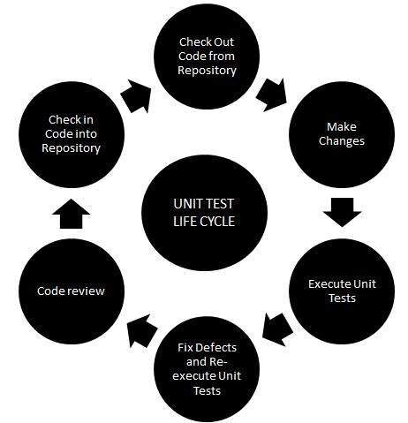
Figure 8. Unit Testing Life Cycle
Unit Testing is important because software developers sometimes try saving time doing minimal unit testing and this is myth because inappropriate unit testing leads to high cost Defect fixing during System Testing, Integration Testing and even Beta Testing after application is built. If proper unit testing is done in early development, then it saves time and money in the end.

4.3.2 Integration Testing
INTEGRATION TESTING is defined as a type of testing where software modules are integrated logically and tested as a group. A typical software project consists of multiple software modules, coded by different programmers. The purpose of this level of testing is to expose defects in the interaction between these software modules when they are integrated
Integration Testing focuses on checking data communication amongst these modules. Hence it is also termed as 'I & T' (Integration and Testing), 'String Testing' and sometimes 'Thread Testing'.
INTEGRATION TESTING is a level of software testing where individual units / components are combined and tested as a group.
21
4.3.3 System Testing
SYSTEM TESTING is a level of testing that validates the complete and fully integrated software product. The purpose of a system test is to evaluate the end-to-end system specifications. Usually, the software is only one element of a larger computer-based system. Ultimately, the software is interfaced with other software/hardware systems. System Testing is actually a series of different tests whose sole purpose is to exercise the full computer-based system.

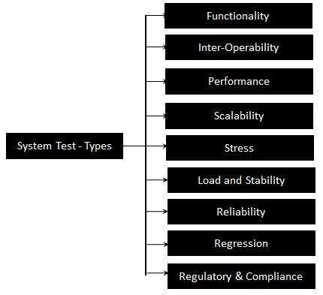

Figure 9. Types Of System Testing

22
CHAPTER 5

CONCLUSION AND RECOMMENDATION

5.1 Conclusion

Online business has many advantages compared to its counterparts such as physical store, the online shopping store allows its user to shop at one place where in physical store the products are scattered at the different places which consumes a lot of time and online business helps in saving that time and it also avoids the problem of unavailability of products at physical store as numerous vendors from different places sell their products at one place. This project is efficient in maintaining users records and can perform operations on it, also reduces the work load on the shop owner of knowing the quantity of products available and which products are available and keeps the records of how many products are purchased and sold.

5.2 Recommendation
System can be improved based upon recommendation- like improvement me UI through user can make use of website very easily.

Future Scope
Software development is never –ending process and continues the life of the software as per the changing needs of the user from time to time. The project is no doubt has been developed keeping in mind easy modification and enhancement that may be required from time to time.

However, there are many scopes to modify this software. As because due to shortage of time, we here become unable to include many things. We are trying to cover all their existing system for sales return records of the items but due to shortage of time we become unable to include many things. Due to lake of time, I here include none of them and a future scope one can develop these returns which are so much essential. Only with a little more doing it is possible to design the formats for those returns.
23
Moreover, an on-line system will be more helpful to the organization. With almost the same data with only a little modification an on-line system can be designed to fulfil their demands. All these can be considered to be future scope for this project.

In terms of future of e-commerce in the 21st century, experts predict the promising and glorious figures. In the foreseeable future, e-commerce will be confirmed as the major tool of sale for the goods and services. Successful e-commerce will become the notion which will be inseparable from the web because e-shopping is becoming more and more popular and natural. Thus, prevailing to future trends, e-commerce will have huge potential growth in sales and promotion.
Each year, there is a continuous growth in e-commerce deals. The volumes of sales for online store are much higher than the brick and mortars. To the present day, the internet sales boom the foundation for magnificent e-commerce future. To attract more customers, owners will not only have to increase the number of services available to them but also have to pay more attention to such elements like design, good presentation, etc.

24
APPENDIX

Screenshots

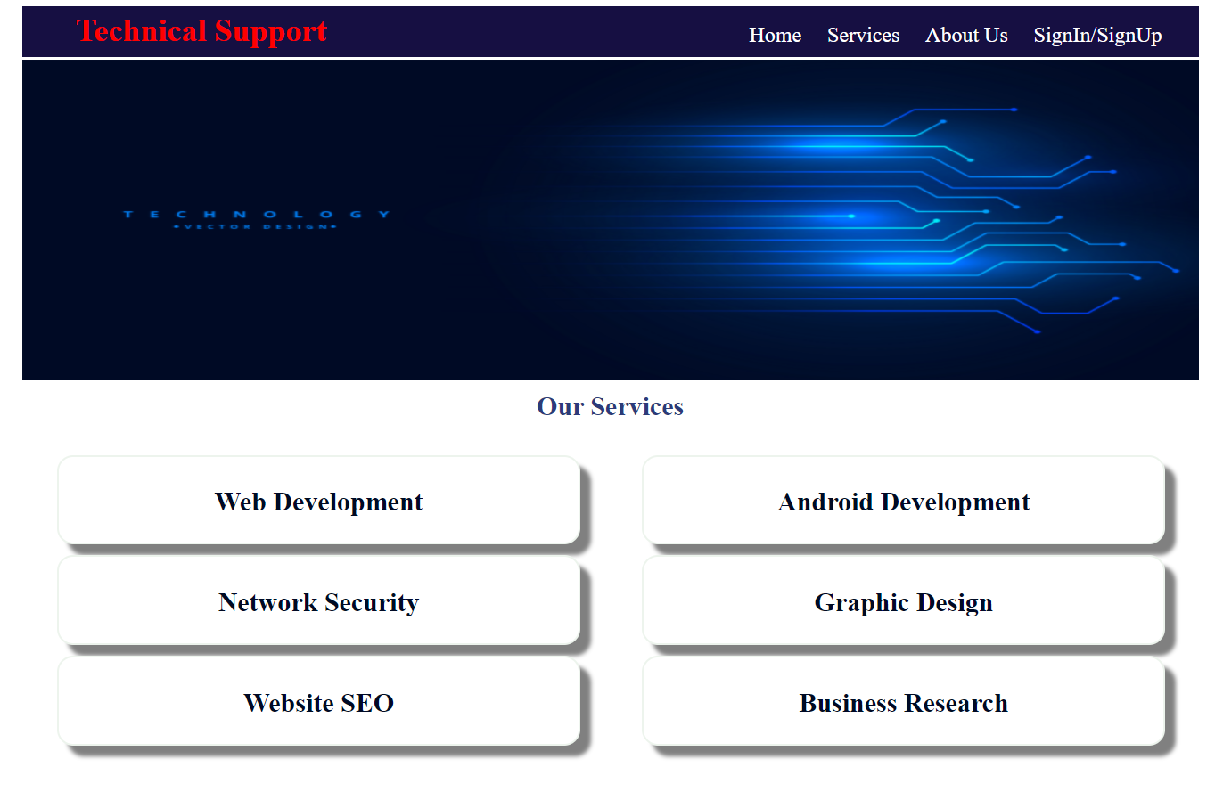
Figure 10. Home

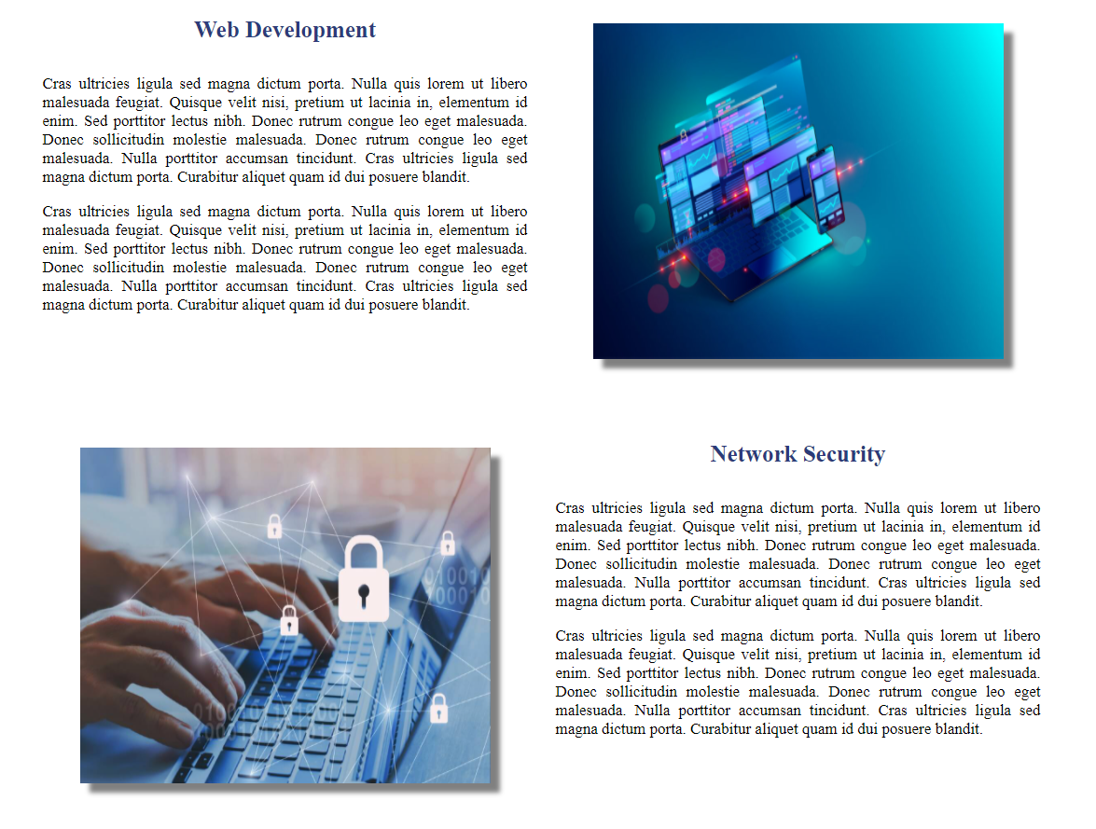

Figure 11. Services
25

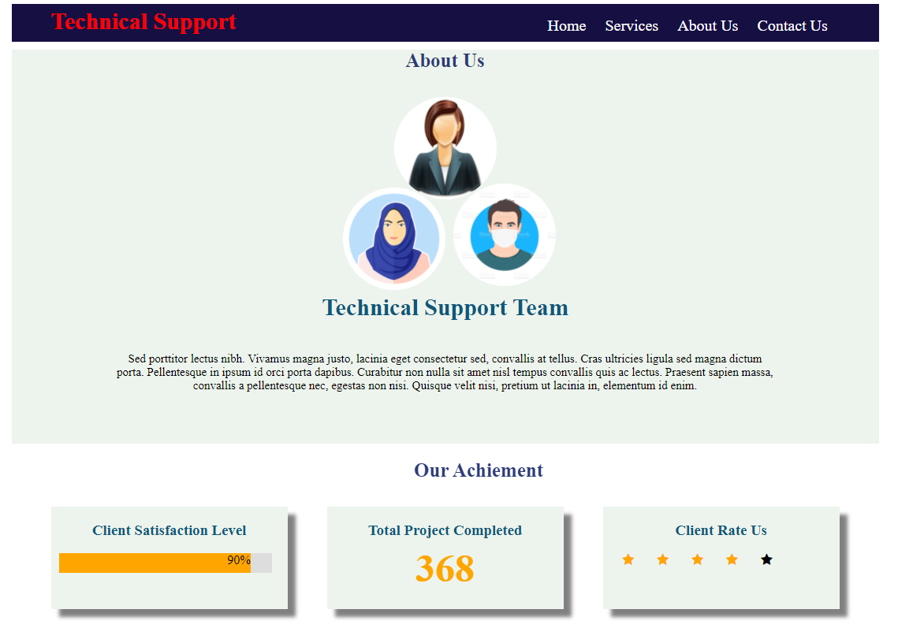

Figure 12. About Us

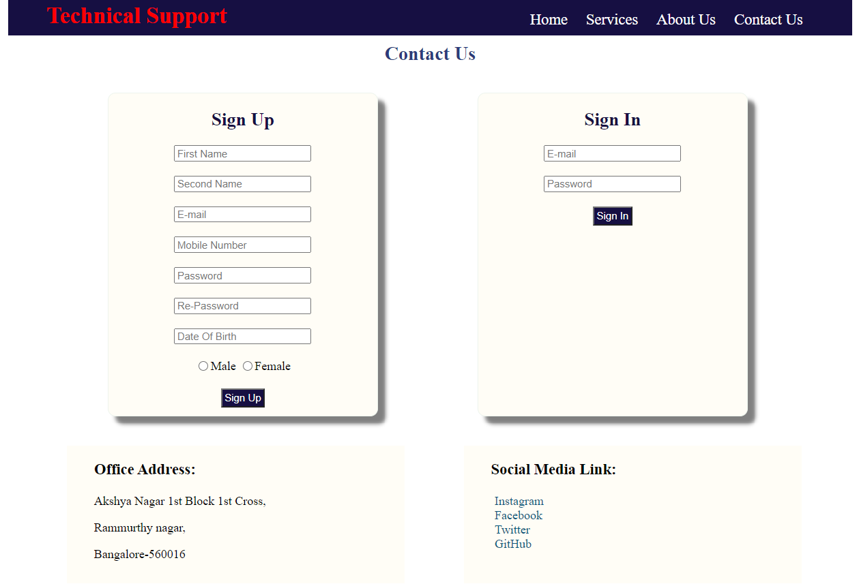

Figure 13. Contact Us

26

Codes

Code of Index.html
<html>
<head>
<title>Home</title>
<style>
.home_page{
height:2825px;
width:1100px;
margin:0 auto;
/*border:1px solid red;*/
}
.navigation{
height:48px;
width:100%;
}
.menu{
height:100%;
width:50%;
float:left;
background-color:#160F42;
}
nav{
height:100%;
width:100%;
margin-left:80px;
}
nav ul{
list-style-type:none;
}
nav ul li{
display:inline;
}
nav ul li a{
font-size:20px;
padding:10px;
text-decoration:none;
color:white;
}
nav ul li a:hover{
color:black;
background-color:white;
}
.menu h2{
color:#FF0000;
font-size:30px;
margin-left:50px;
margin-top:5px;
}
27
.home_slide{
height:300px;
width:100%;
margin-top:2px;
}
.services{
height:380px;
width:100%;
background-color:none;
}
.column{
height:330px;
width:49%;
background-color:none;
float:left;
margin-left:8px;
}
.service{
height:80px;
width:90%;
margin-top:10px;
margin-left:25px;
background-color:#FFFFFF;
border:2px solid #EDF4ED;
border-radius:15px;
box-shadow:10px 10px 4px gray;
}
.service h2{
font-size:25px;
text-align:center;
padding-top:7px;
color:#000A25;
}
.why_b_req{
height:410px;
width:100%;
background-color:none;
}
.why_b_req p{
text-align:justify;
display:block;
}
.title{
height:50px;
width:100%;
background-color:none;
}
.title h1{
margin-top:10px;
text-align:center;
font-size:25px;
color:#2C3B79; 28
}
.Technology_use{
margin-top:10px;
height:250px;
width:100%;
background-color:none;
}
.icon_frame{
margin-top:20px;
margin-left:5px;
height:170px;
width:100%;
background-color:#F5F6F6;
}
.box{
margin-top:20px;
margin-left:5px;
height:90px;
width:150px;
float:left;
}
figcaption{
text-align:center;
color:#000A25;
}
.testimonial{
height:660px;
width:100%;
background-color:none;
}
.testimonial_box{
padding-left: 7px;
padding-right: 7px;
margin-top:5px;
height:140px;
width:99.8%;
background-color:#ECF1E7;
border:2px solid #C4CCBA;
border-radius:10px;
}
.testimonial_box p{
text-align:justify;
display:block;
}
.testimonial_box img {
margin-top:15px;
height:70%;
float: left;
margin-left: 20px;
border-radius: 50%;
}
.testimonial_box span{ 29
margin-left:10px;
color:#B64029;
}
.testimonial_box p{
text-align:justify;
}
.ties_comp{
height:250px;
width:100%;
background-color:none;
}
.why_client_choose_us{
height:350px;
width:100%;
background-color:none;
}
.why_client_choose_us p{
text-align:justify;
display:block;
margin-left:3px;
margin-right:3px;
}
footer{
margin-top:5px;
height:90px;
width:100%;
background-color:black;
}
footer p{
color:white;
text-align:center;
font-size:15px;
}
</style>
</head>
<body>
<section class="home_page">
<section class="navigation">
<section class="menu">
<h2>Technical Support</h2>
</section>
<section class="menu">
<nav>
<ul>
<li><a href="#">Home</a></li>
<li><a href="services.html">Services</a></li>
<li><a href="about_us.html">About Us</a></li>
<li><a href="contact_us.html">SignIn/SignUp</a></li>
</ul>
</nav>
</section>
</section> 30
<section class="home_slide">
<img src="images\home_slider.jpg" alt="Simply Easy Learning" width="100%" height="100%">
</section>
<section class="services">
<section class="title"><h1>Our Services</h1></section>
<section class="column">
<section class="service"><h2>Web Development</h2></section>
<section class="service"><h2>Network Security</h2></section>
<section class="service"><h2>Website SEO</h2></section>
</section>
<section class="column">
<section class="service"><h2>Android Development</h2></section>
<section class="service"><h2>Graphic Design</h2></section>
<section class="service"><h2>Business Research</h2></section>
</section>
</section>
<section class="why_b_req">
<section class="title"><h1>Why Business Required Technology</h1></section>
<p>Vivamus magna justo, lacinia eget consectetur sed, convallis at tellus. Nulla porttitor accumsan tincidunt. Vivamus magna justo, lacinia eget consectetur sed, convallis at tellus. Nulla porttitor accumsan tincidunt. Curabitur non nulla sit amet nisl tempus convallis quis ac lectus. Vestibulum ac diam sit amet quam vehicula elementum sed sit amet dui. Lorem ipsum dolor sit amet, consectetur adipiscing elit. Praesent sapien massa, convallis a pellentesque nec, egestas non nisi. Proin eget tortor risus. Nulla quis lorem ut libero malesuada feugiat.</p>
</section>
<section class="Technology_use">
<section class="title"><h1>Technology We Use</h1></section>
<section class="icon_frame">
<section class="box"><figure><img src="images\angularjs.png" align="center"width="100%"height="100%"><figcaption>Angularjs</figcaption></figure></section>
<section class="box"><figure><img src="images\css3.png" align="center"width="100%"height="100%"><figcaption>CSS3</figcaption></figure></section>
<section class="box"><figure><img src="images\django.png" align="center"width="100%"height="100%"><figcaption>Django</figcaption></figure></section>
<section class="box"><figure><img src="images\bootstrap.png" align="center"width="100%"height="100%"><figcaption>Bootstrap</figcaption></figure></section>
<section class="box"><figure><img src="images\couchdb.png" align="center"width="100%"height="100%"><figcaption>Couchdb</figcaption></figure></section>
<section class="box"><figure><img src="images\github.png" align="center"width="100%"height="100%"><figcaption>GitHub</figcaption></figure></section>
<section class="box"><figure><img src="images\rubymine.png" align="center"width="100%"height="100%"><figcaption>Rubymine</figcaption></figure></section>
</section>
</section>
<section class="testimonial">
<section class="title"><h1>What People Say About Us</h1></section>
<section class="testimonial_box">
<img src="images\\female-avatar.png" alt="Avatar" style="width:90px">
<p><span>Chris Fox.</span> CEO at Mighty Business.</p>
31
<p>John Doe saved us from a web disaster.Mauris blandit aliquet elit, eget tincidunt nibh pulvinar a. Proin eget tortor risus. Quisque velit nisi, pretium ut lacinia in, elementum id enim. Curabitur non nulla sit amet nisl tempus convallis quis ac lectus. Quisque velit nisi, pretium ut lacinia in, elementum id enim. Nulla quis lorem ut libero malesuada feugiat</p>
</section>
<section class="testimonial_box">
<img src="images\\male-profile-avatar-with-brown-hair-vector-12055105.jpg" alt="Avatar" style="width:90px">
<p><span>Chris Fox.</span> CEO at Mighty Business.</p>
<p>John Doe saved us from a web disaster.Mauris blandit aliquet elit, eget tincidunt nibh pulvinar a. Proin eget tortor risus. Quisque velit nisi, pretium ut lacinia in, elementum id enim. Curabitur non nulla sit amet nisl tempus convallis quis ac lectus. Quisque velit nisi, pretium ut lacinia in, elementum id enim. Nulla quis lorem ut libero malesuada feugiat</p>
</section>
<section class="testimonial_box">
<img src="images\\istockphoto-1222731059-1024x1024.jpg" alt="Avatar" style="width:90px">
<p><span>Chris Fox.</span> CEO at Mighty Business.</p>
<p>John Doe saved us from a web disaster.Mauris blandit aliquet elit, eget tincidunt nibh pulvinar a. Proin eget tortor risus. Quisque velit nisi, pretium ut lacinia in, elementum id enim. Curabitur non nulla sit amet nisl tempus convallis quis ac lectus. Quisque velit nisi, pretium ut lacinia in, elementum id enim. Nulla quis lorem ut libero malesuada feugiat</p>
</section>
<section class="testimonial_box">
<img src="images\\abs-avatar.png" alt="Avatar" style="width:90px">
<p><span>Chris Fox.</span> CEO at Mighty Business.</p>
<p>John Doe saved us from a web disaster.Mauris blandit aliquet elit, eget tincidunt nibh pulvinar a. Proin eget tortor risus. Quisque velit nisi, pretium ut lacinia in, elementum id enim. Curabitur non nulla sit amet nisl tempus convallis quis ac lectus. Quisque velit nisi, pretium ut lacinia in, elementum id enim. Nulla quis lorem ut libero malesuada feugiat</p>
</section>
</section>
<section class="ties_comp">
<section class="title"><h1><marquee>Our Ties With Companies</marquee></h1></section>
<section class="icon_frame">
<section class="box"><figure><img src="images\huawei.png" align="center"width="100%"height="100%"><figcaption>Huawei</figcaption></figure></section>
<section class="box"><figure><img src="images\coca.png" align="center"width="100%"height="100%"><figcaption>Coca-Cola</figcaption></figure></section>
<section class="box"><figure><img src="images\motorola.png" align="center"width="100%"height="100%"><figcaption>Motorola</figcaption></figure></section>
<section class="box"><figure><img src="images\mcdonald.png" align="center"width="100%"height="100%"><figcaption>Mcdonald</figcaption></figure></section>
<section class="box"><figure><img src="images\apple.png" align="center"width="100%"height="100%"><figcaption>Apple</figcaption></figure></section>

32
<section class="box"><figure><img src="images\ceylon.png" align="center"width
="100%"height="100%"><figcaption>Ceylon</figcaption></figure></section>
<section class="box"><figure><img src="images\kfc.png" align="center"width="100%"height="100%"><figcaption>KFC Chicken</figcaption></figure></section>
</section>
</section>
<section class="why_client_choose_us">
<section class="title"><h1>Why Client Choose Us</h1></section>
<p>Vivamus magna justo, lacinia eget consectetur sed, convallis at tellus. Nulla porttitor accumsan tincidunt. Vivamus magna justo, lacinia eget consectetur sed, convallis at tellus. Nulla porttitor accumsan tincidunt. Curabitur non nulla sit amet nisl tempus convallis quis ac lectus. Vestibulum ac diam sit amet quam vehicula elementum sed sit amet dui. Lorem ipsum dolor sit amet, consectetur adipiscing elit. Praesent sapien massa, convallis a pellentesque nec, egestas non nisi. Proin eget tortor risus. Nulla quis lorem ut libero malesuada feugiat.</p>
</section>
<footer>
<p>All right reserved to Technical Support 2020</p>
<p>Nulla porttitor accumsan tincidunt. Cras ultricies ligula sed magna dictum porta. Vivamus suscipit tortor eget felis porttitor volutpat. Praesent sapien massa, convallis a pellentesque nec, egestas non nisi. Curabitur non nulla sit amet nisl tempus convallis quis ac lectus.</p>
</footer>
</section>
</body>
</html>

Code of services.html

<html>
<head>
<title>Services</title>
</head>
<section class="service_slide">
<img src="images\Technical-Support-Web-banner.png" alt="Simply Easy Learning" width="100%" height="100%">
</section>
<section class="web_dev">
<section class="definition">
<h1>Web Development</h1>
<p>Cras ultricies ligula sed magna dictum porta. Nulla quis lorem ut libero malesuada feugiat. Quisque velit nisi, pretium ut lacinia in, elementum id enim. Sed porttitor lectus nibh. Donec rutrum congue leo eget malesuada. Donec sollicitudin molestie malesuada. Donec rutrum congue leo eget malesuada. Nulla porttitor accumsan tincidunt. Cras ultricies ligula sed magna dictum porta. Curabitur aliquet quam id dui posuere blandit.</p>
</section>
<section class="definition">
<section class="image">
<img src="images\shutterstock_1128653108-
33
1024x605.jpg" alt="Simply Easy Learning" width="100%" height="100%">
</section>
</section>
</section>
<section class="network-security">
<section class="definition">
<section class="image">
<img src="images\network-security.jpg" alt="Simply Easy Learning" width="100%" height="100%">
</section>
</section>
<section class="definition">
<h1>Network Security</h1>
<p>Cras ultricies ligula sed magna dictum porta. Nulla quis lorem ut libero malesuada feugiat. Quisque velit nisi, pretium ut lacinia in, elementum id enim. Sed porttitor lectus nibh. Donec rutrum congue leo eget malesuada. Donec sollicitudin molestie malesuada. Donec rutrum congue leo eget malesuada. Nulla porttitor accumsan tincidunt. Cras ultricies ligula sed magna dictum porta. Curabitur aliquet quam id dui posuere blandit.</p>
</section>
</section>
<section class="web_seo">
<section class="definition">
<h1>Website SEO</h1>
<p>Cras ultricies ligula sed magna dictum porta. Nulla quis lorem ut libero malesuada feugiat. Quisque velit nisi, pretium ut lacinia in, elementum id enim. Sed porttitor lectus nibh. Donec rutrum congue leo eget malesuada. Donec sollicitudin molestie malesuada. Donec rutrum congue leo eget malesuada. Nulla porttitor accumsan tincidunt. Cras ultricies ligula sed magna dictum porta. Curabitur aliquet quam id dui posuere blandit.</p>
</section>
<section class="definition">
<section class="image">
<img src="images\download.jpg" alt="Simply Easy Learning" width="100%" height="100%">
</section>
</section>
</section>
<section class="android_dev">
<section class="definition">
<section class="image">
<img src="images\best-android-app-development-frameworks.jpg" alt="Simply Easy Learning" width="100%" height="100%">
</section>
</section>
<section class="definition">
<h1>Android Development</h1>
<p>Cras ultricies ligula sed magna dictum porta. Nulla quis lorem ut libero malesuada feugiat. Quisque velit nisi, pretium ut lacinia in, elementum id enim. Sed porttitor lectus nibh. Donec rutrum congue leo eget malesuada.

34
Donec sollicitudin molestie malesuada. Donec rutrum congue leo eget malesuada. Nulla porttitor accumsan tincidunt. Cras ultricies ligula sed magna dictum porta. Curabitur aliquet quam id dui posuere blandit.</p>
</section>
</section>
<section class="graphic_dev">
<section class="definition">
<h1>Graphic Design</h1>
<p>Cras ultricies ligula sed magna dictum porta. Nulla quis lorem ut libero malesuada feugiat. Quisque velit nisi, pretium ut lacinia in, elementum id enim. Sed porttitor lectus nibh. Donec rutrum congue leo eget malesuada. Donec sollicitudin molestie malesuada. Donec rutrum congue leo eget malesuada. Nulla porttitor accumsan tincidunt. Cras ultricies ligula sed magna dictum porta. Curabitur aliquet quam id dui posuere blandit.</p>
<p>Cras ultricies ligula sed magna dictum porta. Nulla quis lorem ut libero malesuada feugiat. Quisque velit nisi, pretium ut lacinia in, elementum id enim. Sed porttitor lectus nibh. Donec rutrum congue leo eget malesuada. Donec sollicitudin molestie malesuada. Donec rutrum congue leo eget malesuada. Nulla porttitor accumsan tincidunt. Cras ultricies ligula sed magna dictum porta. Curabitur aliquet quam id dui posuere blandit.</p>
</section>
<section class="definition">
<section class="image">
<img src="images\Graphics-Designing-Tips-And-Scope-For-Students.jpg" alt="Simply Easy Learning" width="100%" height="100%">
</section>
</section>
</section>
<section class="busines_dev">
<section class="definition">
<section class="image">
<img src="images\AdobeStock_208955675-1024x684.jpeg" alt="Simply Easy Learning" width="100%" height="100%">
</section>
</section>
<section class="definition">
<h1>Business Research</h1>
<p>Cras ultricies ligula sed magna dictum porta. Nulla quis lorem ut libero malesuada feugiat. Quisque velit nisi, pretium ut lacinia in, elementum id enim. Sed porttitor lectus nibh. Donec rutrum congue leo eget malesuada. Donec sollicitudin molestie malesuada. Donec rutrum congue leo eget malesuada. Nulla porttitor accumsan tincidunt. Cras ultricies ligula sed magna dictum porta. Curabitur aliquet quam id dui posuere blandit.</p>
</section>
</section>
<section class="video_frame" style="text-align:center">
<h2>Out Door Team Meating</h2>
<video height="350" width="auto" controls>
<source src="images\video.mp4" type="video/mp4">
</video>
</section>
35
<footer>
<p>All right reserved to Technical Support 2020</p>
<p>Nulla porttitor accumsan tincidunt. Cras ultricies ligula sed magna dictum porta. Vivamus suscipit tortor eget felis porttitor volutpat. Praesent sapien massa, convallis a pellentesque nec, egestas non nisi. Curabitur non nulla sit amet nisl tempus convallis quis ac lectus.</p>
</footer>
</section>
</body>
</html>

Codes of contact.html

<html>
<head>
<title>Contact Us</title>
</head>
<section class="contact">
<section class="title"><h1>Contact Us</h1></section>
<section class="column">
<h2 align="center">Sign Up</h2>
<form align="center" border="1" >
<input type="text" placeholder="First Name"><br><br>
<input type="text"placeholder="Second Name"><br><br>
<input type="email"placeholder="E-mail"><br><br>
<input type="text" placeholder="Mobile Number"><br><br>
<input type="password"placeholder="Password"><br><br>
<input type="password"placeholder="Re-Password"><br><br>
<input type="datetime"placeholder="Date Of Birth"><br><br>
<input type="radio" name="red_type">Male
<input type="radio" name="red_type">Female<br><br>
<input type="submit" class="button" value="Sign Up">
</form>
</section>
<section class="column">
<h2 align="center">Sign In</h2>
<form align="center" border="1" >
<input type="email"placeholder="E-mail"><br><br>
<input type="password"placeholder="Password"><br><br>
<input type="submit" class="button" value="Sign In">
</form>
</section>
</section>
<section class="addr">
<section class="find">
<h3>Office Address:</h3>
<p>Akshya Nagar 1st Block 1st Cross,</p>
<p> Rammurthy nagar,</p>
<p> Bangalore-560016</p>
</section>
36
<section class="find">
<h3>Social Media Link:</h3>
<ul>
<li><a href="https://www.instagram.com/?hl=en">Instagram</a></li>
<li><a href="https://www.facebook.com/">Facebook</a></li>
<li><a href="https://twitter.com/explore">Twitter</a></li>
<li><a href="https://github.com/kayyum859/StaticWeb">GitHub</a></li>
</ul>
</section>
</section>
<section class="office_time_table">
<h2>Office Time Table:</h2>.
<table id="office_time">
<tr>
<th>DAY</th>
<th>OPEN</th>
<th>CLOSE</th>
</tr>
<tr>
<td>MONDAY</td>
<td>09:30 AM</td>
<td>04:00 PM</td>
</tr>
<tr>
<td>TUESDAY</td>
<td>09:30 AM</td>
<td>04:00 PM</td>
</tr>
<tr>
<td>WEDNSDAY</td>
<td>09:30 AM</td>
<td>04:00 PM</td>
</tr>
<tr>
<td>TURSDAY</td>
<td>09:30 AM</td>
<td>04:00 PM</td>
</tr>
<tr>
<td>FRIDAY</td>
<td>09:30 AM</td>
<td>04:00 PM</td>
</tr>
<tr>
<td>SATURDAY</td>
<td>09:30 AM</td>
<td>12:00 AM</td>
</tr>
<tr>
<td>SUNDAY</td>
37
<td>OFF</td>
<td>OFF</td>
</tr>
</table>
</section>
<footer>
<p>All right reserved to Technical Support 2020</p>
<p>Nulla porttitor accumsan tincidunt. Cras ultricies ligula sed magna dictum porta. Vivamus suscipit tortor eget felis porttitor volutpat. Praesent sapien massa, convallis a pellentesque nec, egestas non nisi. Curabitur non nulla sit amet nisl tempus convallis quis ac lectus.</p>
</footer>
</section>
</body>
</html>

38
BIBLIOGRAPHY
- Todd Stauffer, “HTML Web Publishing 6-in-1”, Que press, 1997
- “HTML, XHTML AND CSS BIBLE”, by Steven M

39
REFERENCES
[1] Ms. Pragati Bagmare1 , Ms. Shraddha Girhepunje2 , Ms. Priya Bisen, “Research Paper on Online business Management System”, International Journal for Research in Applied Science & Engineering Technology (IJRASET), Volume 5., Issue 4., 2017, page no. 115-117.
[2] Fatin Najwa Binti Abdullah Sani1 , Hani Malini binti Majek2 , Umairah binti Ahmad Khairudin3 , Abdul Rahman bin Ahmad Dahlan4, “e-commerce: Opening Door to the Garden of Knowledge”, International Journal of Scientific and Research Publications, Volume 7, Issue 6, June 2017 ,page no. 2250-3153
[3] Vamsi Krishna Mummaneni ,A Report Submitted in partial fulfillment of the requirements of the degree of Master of Software Engineering

40

